Introduction
This comprehensive manual is designed to assist you in efficiently managing property, vendor and applicant / buyer details through our integrated system. Whether you're a new user or an experienced professional, this guide provides step-by-step instructions and best practices to streamline your workflow and enhance your experience with our platform.

Purpose of the Guide
The primary purpose of this user guide is to facilitate a seamless transition and integration of data between Reapit's Agency Cloud and movebutler. By leveraging our automated tools, you can significantly reduce manual data entry, minimise errors, and save valuable time. This guide will walk you through the entire process, from initial setup to advanced features, ensuring you have all the information needed to make the most of our system.

Key Benefits
Efficiency: Automate data transfers and reduce repetitive tasks.
Accuracy: Minimise errors by ensuring consistent data entry.
User-Friendly: Step-by-step instructions make it easy to navigate and utilise the movebutler app.

How to Use This Guide
Each section of this guide is structured to provide clear and concise instructions. We recommend starting with the basics and progressing through the sections in order.

User guide video
Below is a link to a short video showing the full process
https://vimeo.com/manage/videos/999577168/a99508aa81

Section 1: Transferring Property and Vendor Details to movebutler
In this section, we will guide you through the streamlined process of transferring property and vendor details from Reapit’s Agency Cloud to movebutler. This integration eliminates the need for manual copying and pasting, ensuring a more efficient and error-free workflow.
You'll learn how to seamlessly move data between these platforms, making the transition smoother and more reliable.
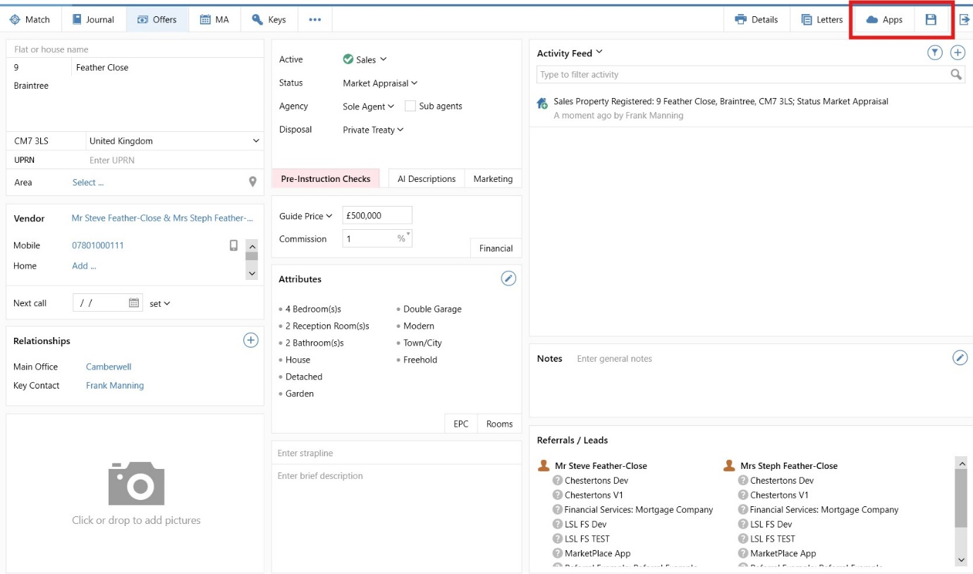

Load the Property in Reapit:
Begin by locating and loading the specific property within Reapit’s Agency Cloud.
Complete Property Address and Vendor Details:
Verify and update the property address and vendor details. Ensure all relevant fields are filled out, as this will be crucial for a smooth data transfer to Movebutler.
Send to movebutler
Select the movebutler app via the “Apps” button in Agency Cloud (top right).
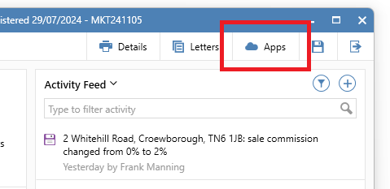

Log into movebutler

When you launch the movebutler app for the first time, you will be prompted to enter your movebutler username and password. This authentication step is required only once, as it grants the app access to your movebutler account. After successfully logging in, the app will securely store your credentials for future sessions.

Sending the property to movebutler.

The app will open with the page where you will send the property and vendors to movebutler.

Click the blue ‘Send to movebutler’ button.
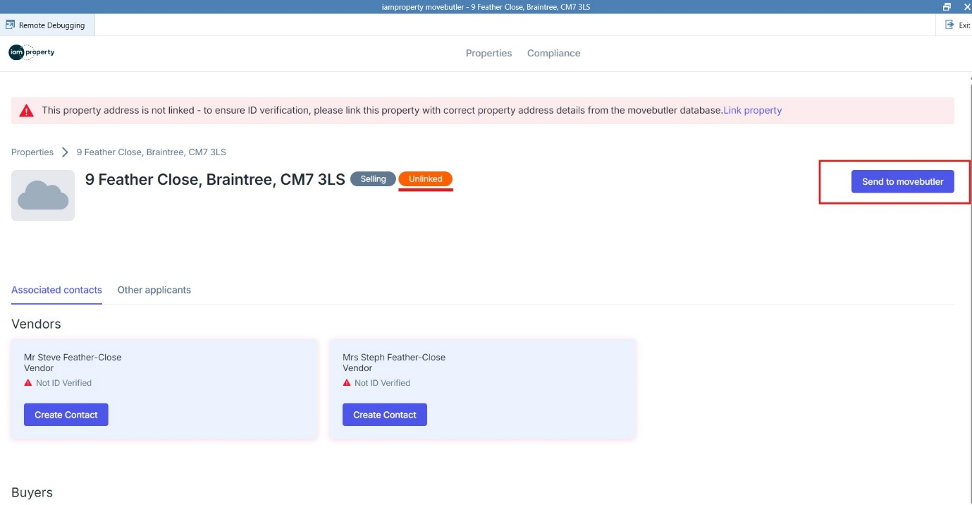
The page will now show the property information and the fields to be completed.
Please complete fields:
- movebutler branch
- Tenure
- Property type
- Method of sale
- Transaction type
Click the blue ‘Submit’ button at the bottom of the page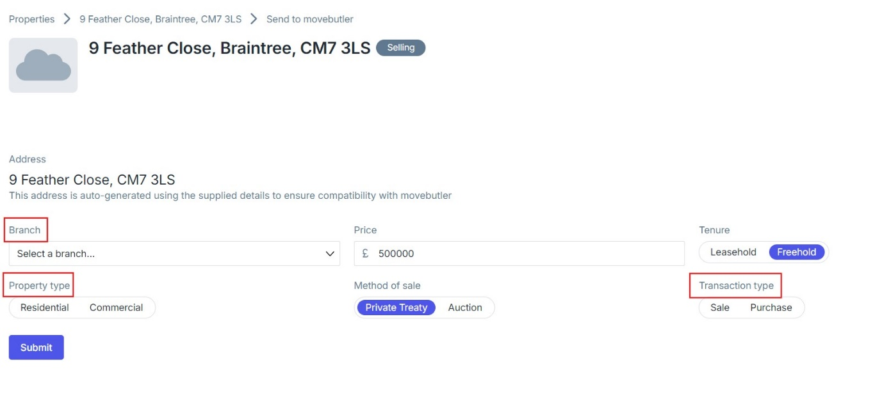

The page will now update and show a trash can ‘Unlink’ button.
This is confirmation the property has been sent to movebutler.
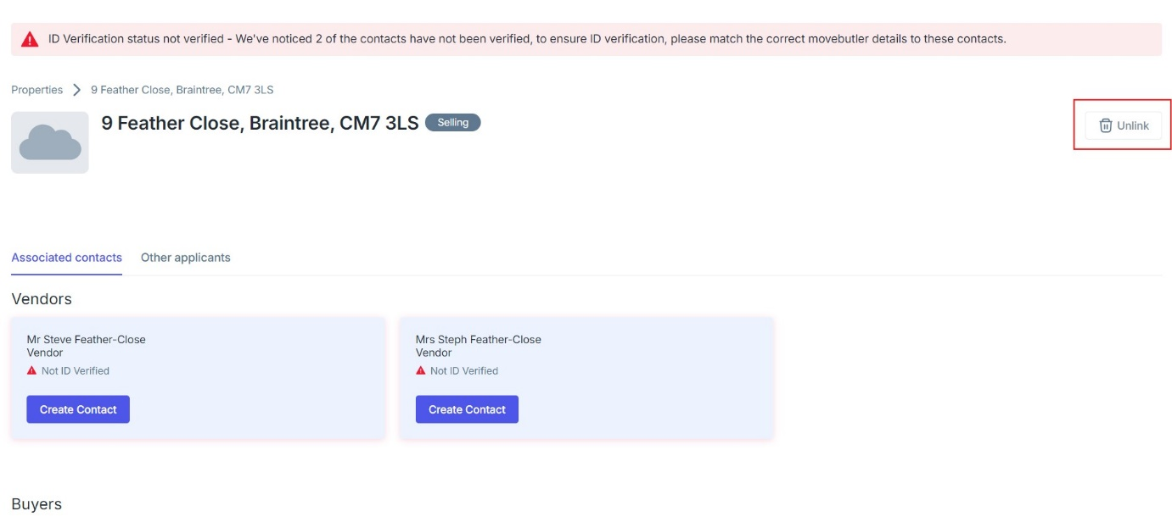

Sending the Vendor(s) to movebutler.
You will now proceed to send the vendor(/s) to movebutler.
Click the blue ‘Create contact’ button under the Vendor name
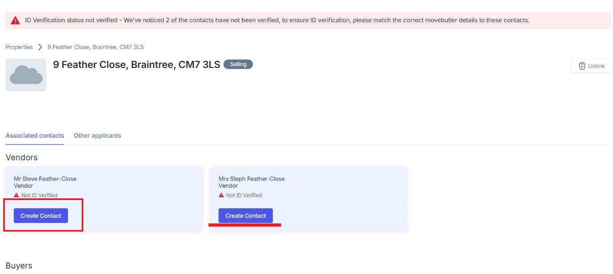

You will now be prompted to complete the vendor details which will include adding the telephone number and selecting your movebutler branch. You are also able to add a middle name, if required.
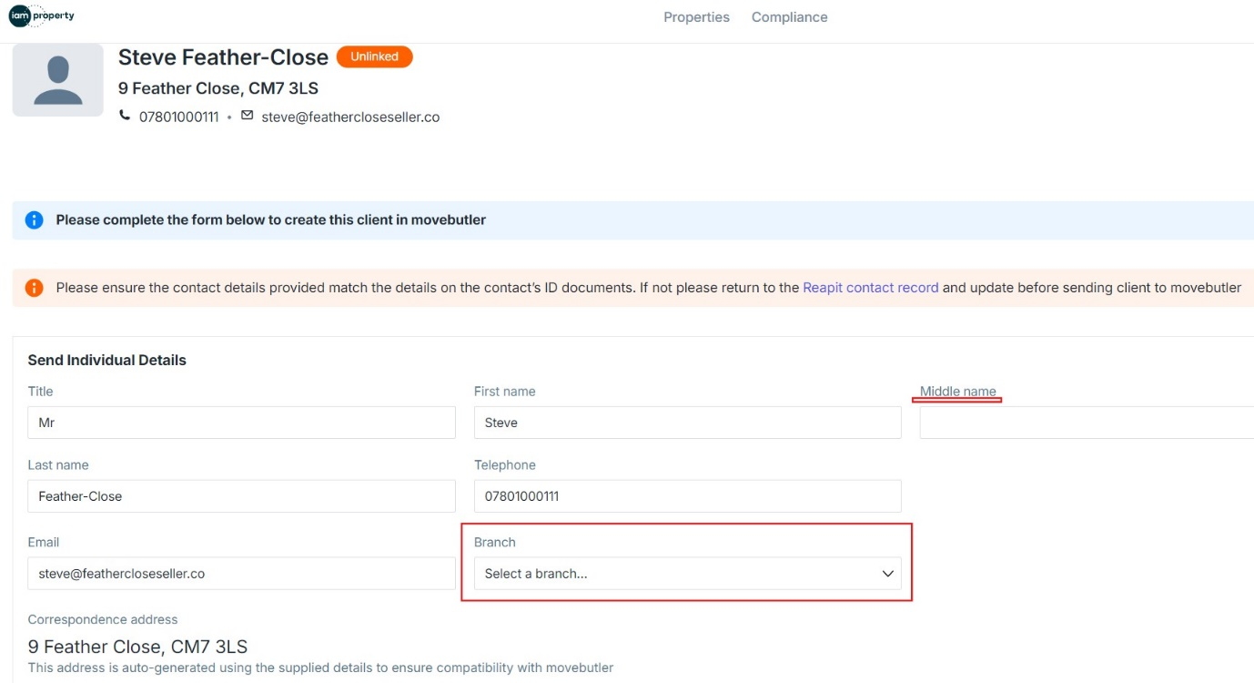
Click the blue ‘Send to movebutler’ button.
The page will update and show an ‘unlink contact’ button. This confirms the client details have been sent to movebutler.

You can now repeat the process to send any additional Vendor details to movebutler
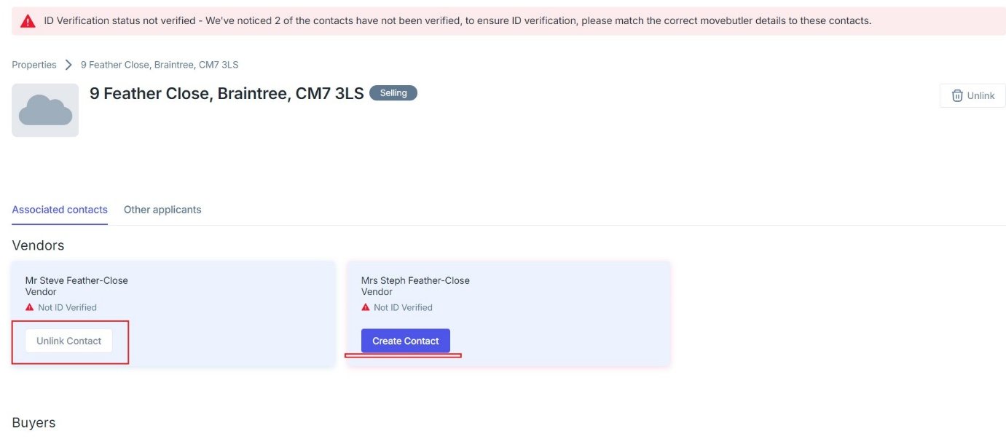
Confirming the property has been sent to movebutler & adding Vendors to the transaction.

To confirm the property has been sent to movebutler, navigate to your movebutler account.
The property will appear at the top of the “Property Audit” page.
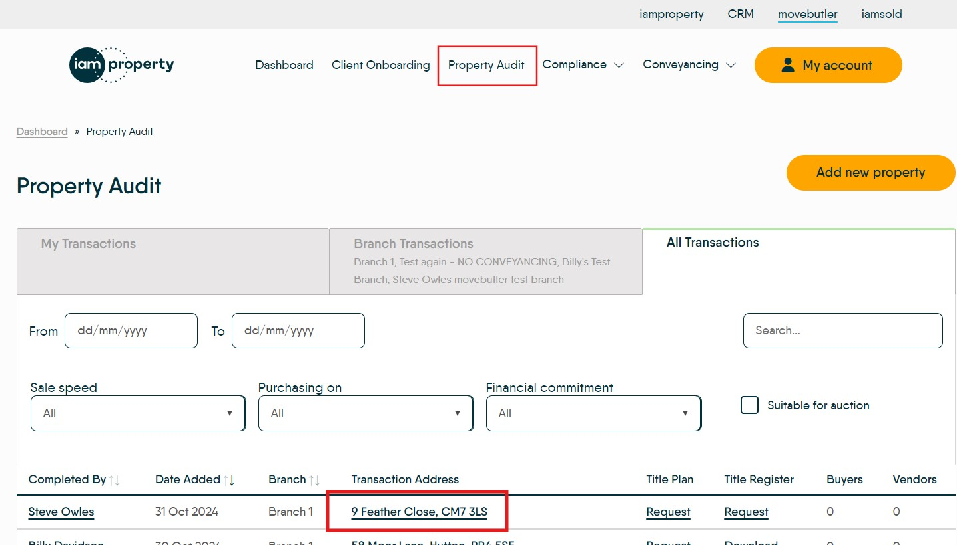

Click the address to open the transaction.

Ordering the Title Register
You can now proceed to order the Title Register for this property transaction.
On the Transaction Overview page, click on ‘Title Register Checks’ to open the menu then click the Order a Title Register button.
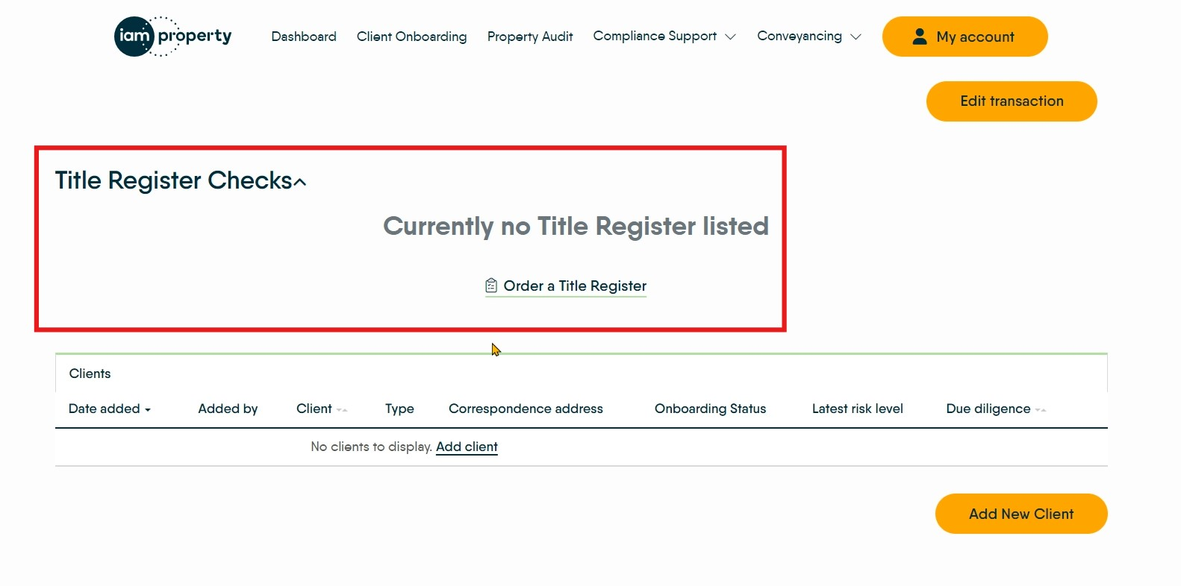
Follow the flow to order the title register.
Once ordered, click on the address link at the top of the page to navigate back to the Transaction Overview page.
You’re now ready to add the clients you have sent from Reapit.
Click the ‘Add new client’ button. Your client can be found using the ‘Find existing client’ search bar.
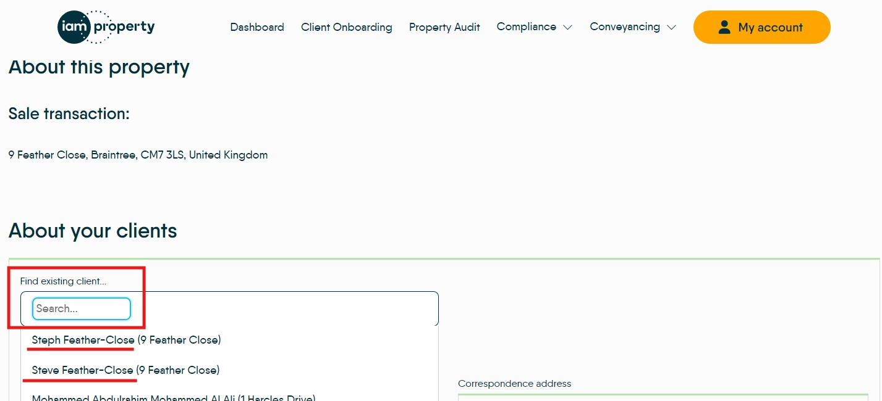

Click on the client’s name and then proceed as normal to populate:
- Vendor
- Title
- County / Country
- Capacity
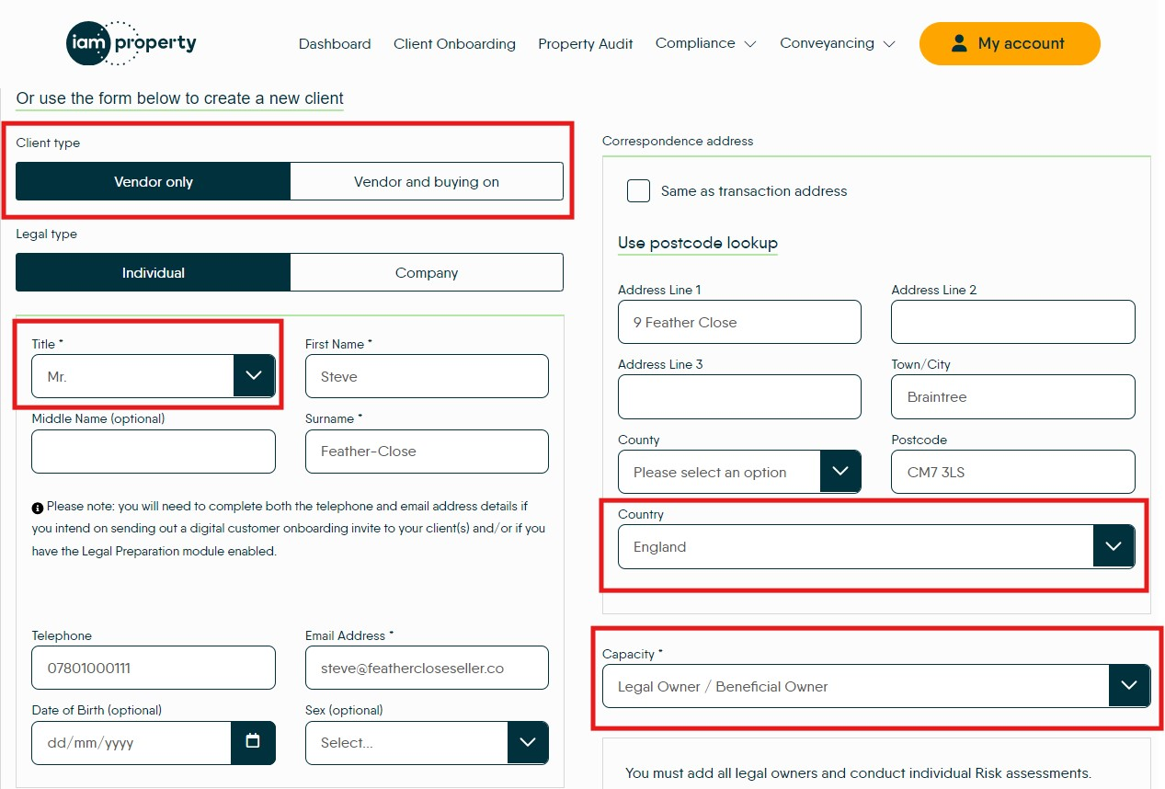
You can now proceed as normal and decide whether you’re sending your client a digital invitation or going to continue in platform

Section 2: Transferring Buyer Details to movebutler
In this section, we will guide you through the streamlined process of transferring buyer details from Reapit’s Agency Cloud to movebutler. This integration eliminates the need for manual copying and pasting, ensuring a more efficient and error-free workflow.
You'll learn how to seamlessly move data between these platforms, making the transition smoother and more reliable.
Load the Property in Reapit:
Begin by locating and loading the specific property within Reapit’s Agency Cloud.
Complete Buyer/Applicant Details:
Verify and update the buyer/applicant details. Ensure all relevant fields are completed, as this will be crucial for a smooth data transfer to movebutler.
Send to movebutler
Select the movebutler app via the “Apps” button in Agency Cloud (top right).
The app will now load with the Buyer/Applicant details populated.
The applicant with the pending offer will be populated into the ‘Other Applicants’ column.
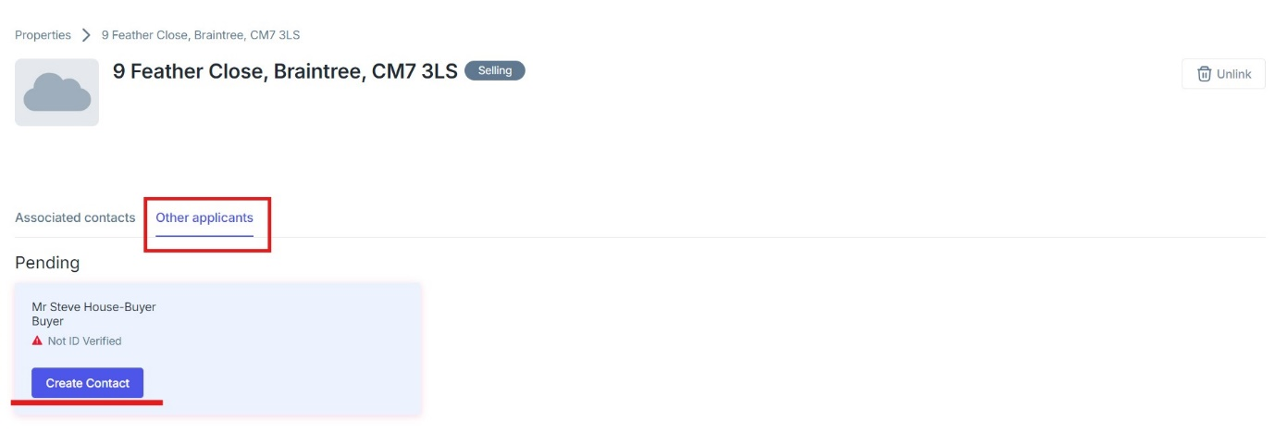
We will now follow the same process as previously used for sending the Vendor to movebutler.
Click the blue ‘Create contact’ button under the Buyer’s name.
Populate all the fields on the page including:
- Telephone
- Email
- Movebutler branch

Click the blue ‘Send to movebutler’ button
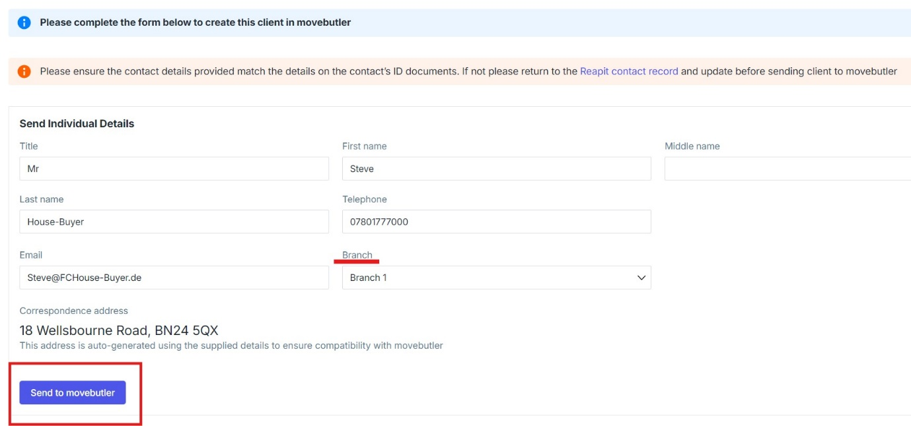

The screen will now update to show the ‘Unlink contact’ button under the buyer name. This is confirmation the buyer details have been sent to movebutler.
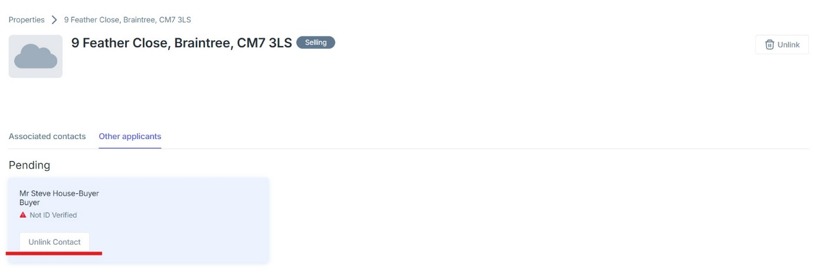

Now navigate to movebutler, into the property transaction to add the buyer into the transaction. Click the yellow ‘Add new client’ button and using the ‘Find existing client’ button
You are now in the normal flow of adding a client. Ensure you complete the relevant fields and then choose the preferred onboarding route for your client.

Once you have completed due diligence on the applicant/buyer the status under the name will change to ID Verified.
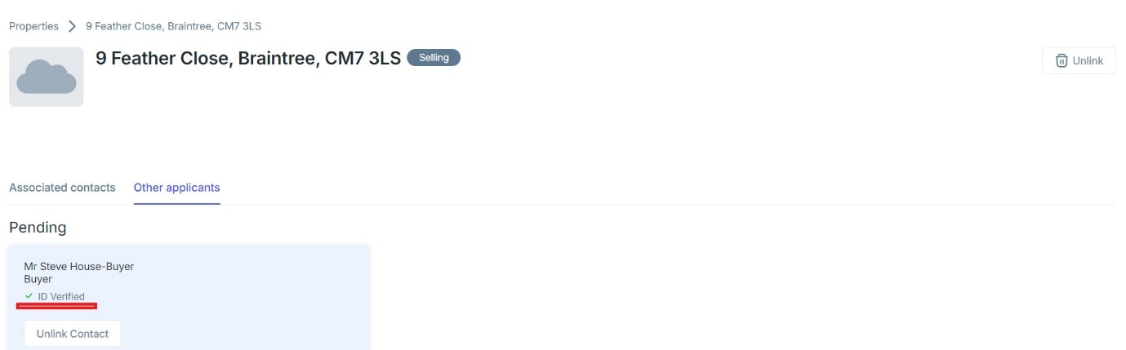
If you now Accept the offer in Reapit and save, the applicant will move to the ‘Associated Contacts’ column (from the ‘Other Applicants column’ and will be shown as the Buyer
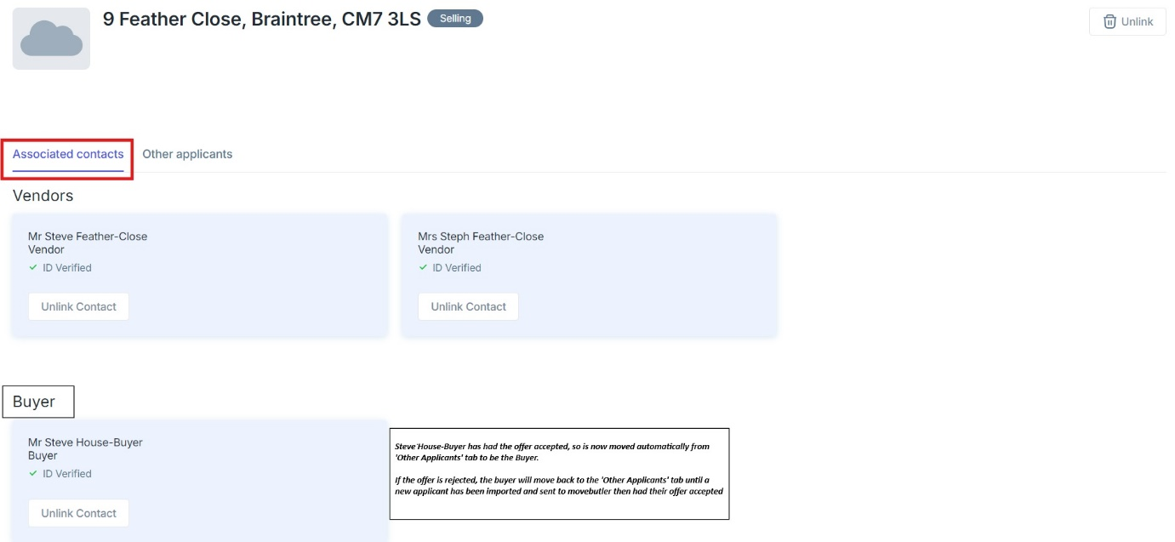
If that Buyer subsequently has their offer rejected and this is reflected in Reapit, this contact will move back to the ‘Other Applicants’ column and will show as Rejected.

Any new offers will be shown in this column, and you can follow process to send to movebutler.
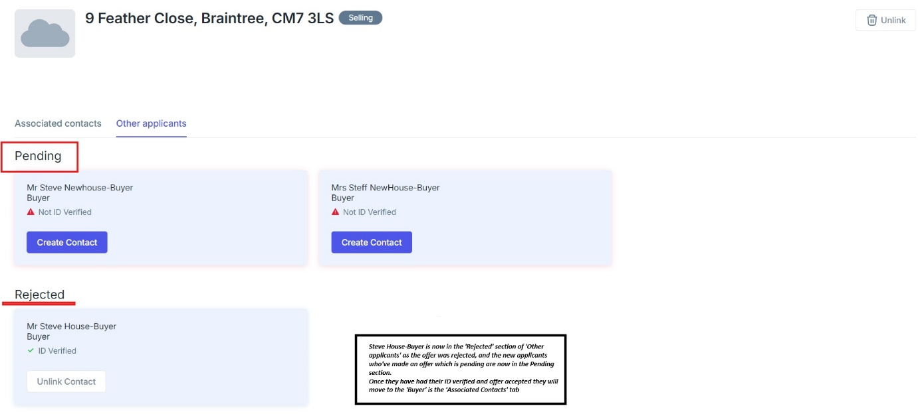
When this new offer has been accepted in Reapit and saved, these applicants will move to the ‘Associated contacts’ column as Buyers
